Remote Learning Guidance

During this period of school closures, the main way in which teachers will set tasks and children will submit their work is via Seesaw. The children should have their login details for this. If they don’t, you can email itsupport@pgps.porticoacademytrust.co.uk and someone will get back to you with their password and instructions for how to log in.
Work should be submitted by children by the end of the normal school day. This enables teachers time to mark the work. If work has to be completed later in the day, the teacher may not be able to mark the work until the following day.
Each day the children will receive a live lesson via Microsoft Teams. The times of these lessons will be shared on Seesaw. The children do not need a login for Teams. A link will be shared for the lesson within Seesaw. All they need to do is click on the link and Teams will open in the Teams app or a browser.
The easiest way to access Microsoft Teams is to download the Teams app on whichever device you are using. It is free and available on different platforms. You do not need to log in to Teams. When you click on the link in Seesaw, it will automatically open the Teams app and join the lesson.
If you are not able to download the Teams app, having clicked on the link in Seesaw, you can choose to ‘continue on this browser’. Teams works in most browsers but not Safari.

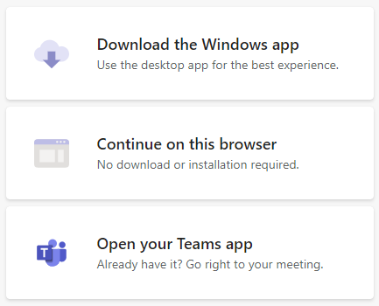

If you have difficulties when connecting to a live lesson, you can email the same address – itsupport@pgps.porticoacademytrust.co.uk – and someone will get back to you. At busy times, such as first thing in the morning, it might take our technician longer to get back to you so please be patient.
This is a different way of working but it is essential that we all adapt as we do not know how long it will last and we need to ensure that the children’s education is affected as little as possible.

